Connect to your home directory as a network drive
It is only possible to gain access to a home directory of a student account or to use other services with a PC within the university network, e. g. to have access to certain web pages. To enter the university network from outside you can either establish a browser-supported VPN connection here or use the VPN client, which you also use to establish an encrypted connection when using the Wi-Fi GoeMobile.

Download and Installation of the VPN client
If you use the VPN client your internet connection is tunneled. That is to say, your PC receives a IP address from the university network. With the VPN connection you can use all these services which would not be possible without a VPN connection.
It is very easy to install the VPN client:
- Go to http://vpn.gwdg.de.
- Log in with your university email-address and your password
- Now follow the instructions on the screen. Normally the program installs automatically.
- When starting the AnyConnect client, enter vpn.gwdg.de for the connection and log in with your university email-address and password.
- After that, a connection should be established. After successful connection the client minimises itself to a padlock icon.

Establish a connection to network drive
Now go to “My Computer” on your PC (start → My Computer). In the Tools menu, click on “Map network drive…”.
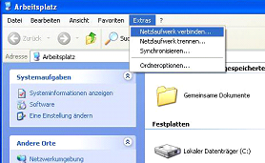
After that, a new window opens. Now choose a letter for the network drive which has not been used yet (here “Z”) and enter into the field Folder the following:
\\samba.student.uni-goettingen.de\home\users\nutzername
Now click on Finish.
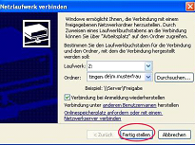
A new window opens where you have to enter your user ID and your password. Please put a ug-student\ in front of your user name. Click OK.
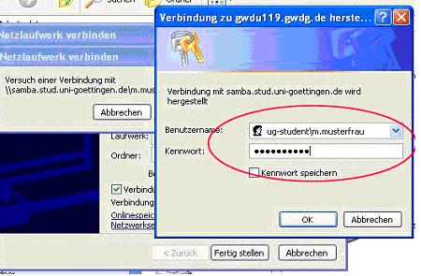
Now a common Windows Explorer page opens which displays your home directory. You can find your saved data in the displayed folders, that is to say in these folders of your home directory where you have once saved your data (Desktop, Eigene Dateien, Eigene Bilder etc.). Now you can work with your files in the same way as you would with your data saved on your computer. In other words, it is possible to open, create, copy or edit files within your home directory.
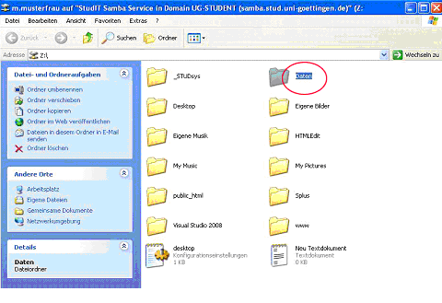
If you want to disconnect, go to “Disconnect Network Drive…” in the Tools menu.

