Copying and saving data on your home directory via WinSCP

1. Download WinSCP
Download the program “WinSCP”, for example from http://winscp.net/eng/docs/lang:de. There are different versions available and an “installation package” which has to be installed on your computer. For saving your data of your home directory it is sufficient to use the “standalone application”, which can be started by double-clicking on the downloaded file without previous installation.

2. Use
After starting WinSCP the following window opens:
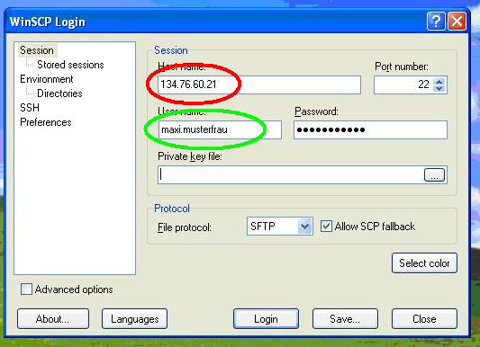
red circle: The host name is the IP-address of the server, that is to say 134.76.60.21 or s1.stud.uni-goettingen.
green circle: Please enter your studIT account as user name (firstname.lastname) and your password on the right hand side. After that, click login, then confirm the request, which opens in a new window if necessary.
After log in successfully the following window opens:
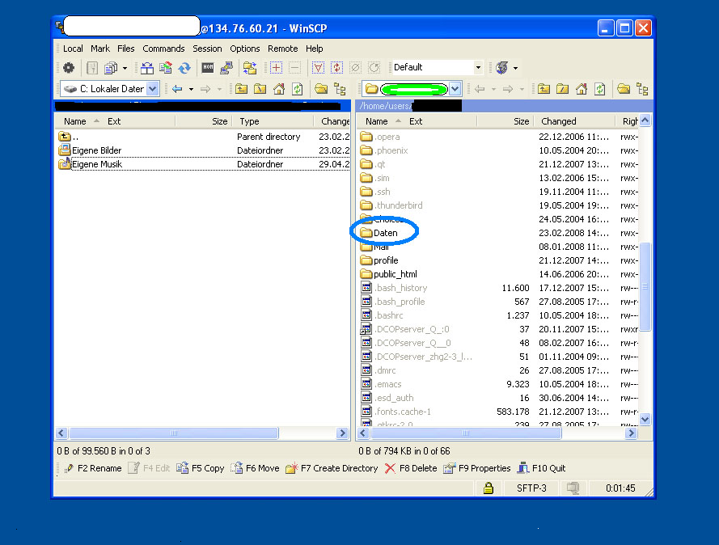
On the left you can see the computer you are sitting in front of. Here you can choose the folder in which you want to copy your data from your home directory. With the selection field above you can also choose a different storage medium. On the right you can see the home directory of your account. In most of the cases data, which you saved on the computers at university, can be found in the folder called “Daten” (highlighted in blue) or directly in the opened directory. Now you can easily copy all data and files per drag and drop (or by clicking on “Copy” or pressing F5).
If you want to copy all data on your hard disk, click on any file in the right window and press strg/ctrl+A to select all. After confirming the request the transfer starts.
The duration of the data transfer depends upon the speed of your internet connection and the data size and may take a while! Once you have copied the data on your computer, just close the program and that is it!
tag>account winscp data copy save home directory
erstellt von | Helena Zimpel
erstellt am | 10.03.2011 16:53

