Your student ID
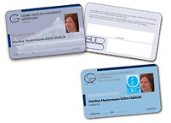
Every properly registered/enroled student at Göttingen University recieves a student ID, also known as chip card. This chip card works as proof of identity, means of payment, semester rail ticket and library membership card.
You'll receive your first student ID at the chip card issue point from our counselors in the main lecture hall building. There you can also renew your semester rail ticket. In case you'll need a new student ID (e.g. in case your first card got lost or has been stolen), you can get it at the Office of Student Affairs, but NOT at the chip card issue point!
This will be all information you'll need about your student ID:

