Printing from your own computer (Ubuntu)
(tested with Ubuntu 11.04, 11.10)
To print with Ubuntu with the studIT printers, a few steps are necessary:

A short instruction
- Via VPN-Client and Goemobile (or another network) authentification.
- Connect printer via CUPS Webinterface at http://localhost:631 through the printserver print-win.student.uni-goettingen.de .
- Download PaperCut Linuxclient from smb://print-win.student.uni-goettingen.de/Install/Client_Nutzer/ and start it (Startscript has to be made achievable).*

Instruction

Networkauthentification
To log in into the university network per VPN-Client. It is important that the user is flawlessly identifiable.

CUPS - Install printer
Set up a connection to the Samba Server via CUPS. In some cases appropriate packages for CUPS or Samba need to be installed out of the package sources („sudo apt-get install smbclient cups cups-client“).
The domain for the CUPS web surface for installing the printer is http://localhost:631
Choose Add printer and class at the CUPS surface 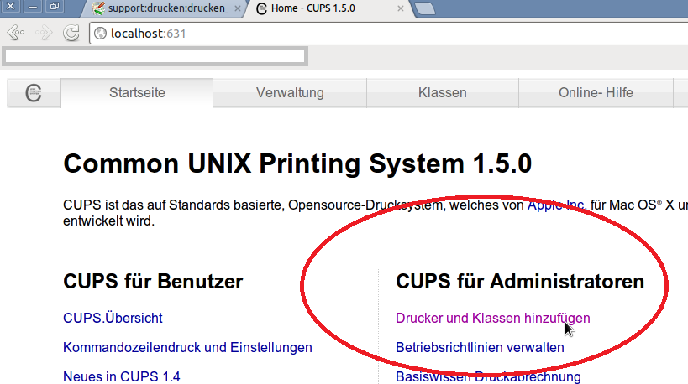
There Add printer
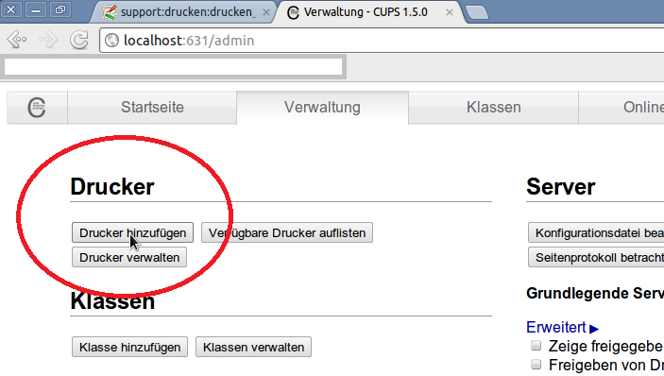
erstellt von | Sandra Klein
erstellt am | 28.02.2012 13:24

