Connecting to a printer (in the LRC SUB and GÖNET,respectively)
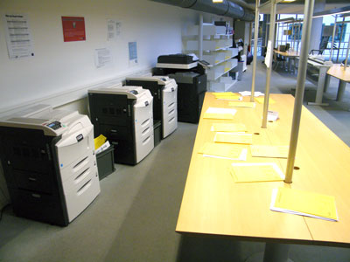
It might be the case that printers at the LRC SUB have not established a connection to the student account yet. That is to say, they do not appear in the list of printers available if students want to print a document.

Solution
In your start menu choose „Printers and Faxes“ („Drucker und Faxgeräte“).
You find this - depending on how you your Start Menu is arranged - either directly in the Start Menu:
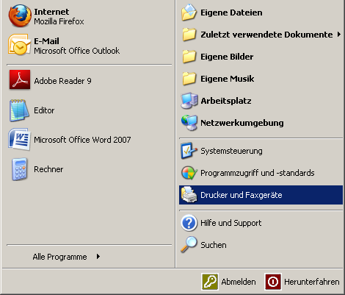
or under „Settings“ (Einstellungen:
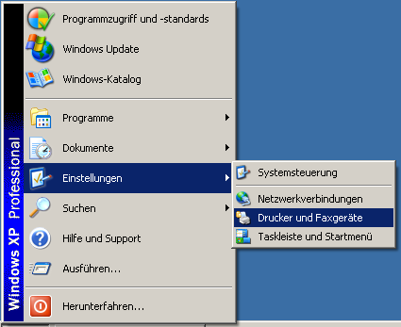
In this new window click on „Add printers“ („Drucker hinzufügen“). In this dialogue box click on „Next“ („Weiter“) three times until a new window called „Search printer“ („Nach Druckern suchen“) appears. The upper field automatically displays the entry „student“, now click on „Search now“ („Jetzt suchen“). The lower field now displays a list of all printers available.
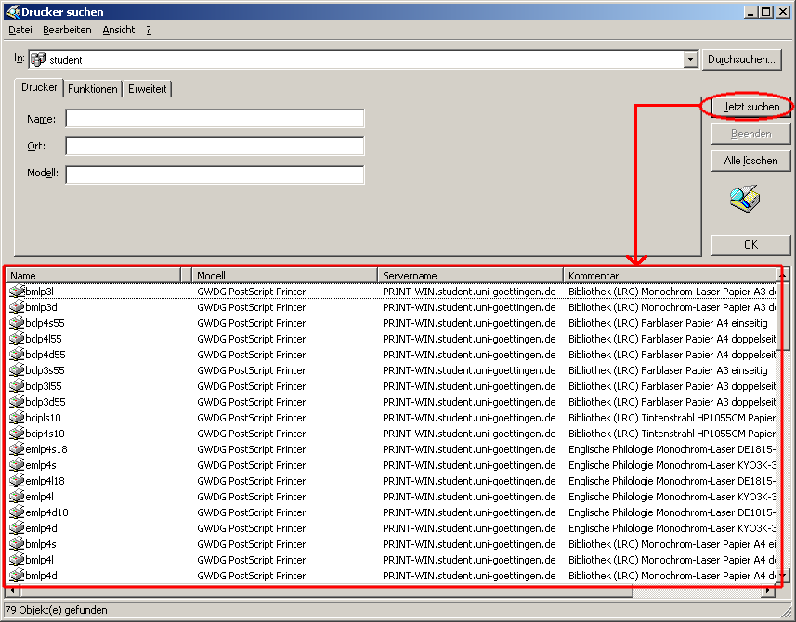
You can find an explanation to all according printers here. You can now install a printer by double-clicking on the printer name. After that you will be able to print out documents on this printer.
tag> printing printer print connect network lrc sub

