Poster Print - Tips
In the LRC SUB you have the chance to print A0-poster for studies relevant or scientific purposes. One print in A0 costs 14€. As you certainly do not want to waste 14€ on a faulty print, you can find a few tips how to correctly create,establish and print poster documents in the following: Basically it applies: If you have questions or if you are unsure, please ask our team before you print something on the poster printer. Unfortunately, we cannot give a refund, if you make any mistakes when printing!

Which printer is the right one?
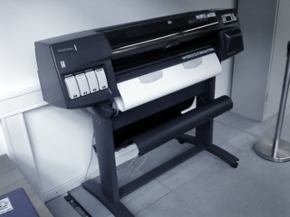
The printer queue of the poster printer has the name bcipls10. If the printer does not show up in the dialogue window of a programme (see images underneath), please ask our consulting team. Der Drucker muss dann noch verbunden werden. Für Nutzer, die sicher im Umgang mit den Rechnern sind wenn keine Beratungszeit ist, gibt es hier auch eine Anleitung dafür.

Which format is right one for the poster printer?
The standard format for the poster printer is A0 (841 mm x 1189 mm). However, the printer cannot print rimless! This means that although the document is in A0, it won´t be printed on the whole paper area. Hence, it is always useful to print documents with the option „In Seite einpassen“ („Fit in page“) (see depiction). If you want to print a poster that includes a lot of white areas, it is recommendable to adjust in the printing dialogue that a margin line or that crop marks should be printed (e.g. extended options in the printing dialogue of Adobe Acrobat). This will facilitate the cutting of the posters, which you can also do in the LRC.

Can I also print other formats?
The paper comes from a paper roll. Hence, you can normally not put your own paper with another format into the machine. You have the opportunity to print two pages on one A0 document. You will then receive two A1 poster. If you choose 4 pages on one paper, you would get 4 A2 poster and so on. An overview for the DIN-formats can be find on the Internet.

Which printing resolution should I choose?
Ideally, you should print with 300dpi. When using 600dpi a lot of data traffic occurs and the print can sometimes take too long or can be rejected by the system. If you choose less than 300 dpi the quality of the print will be quite bad.
erstellt von | Sandra Klein
erstellt am | 27.03.2012 11:58

