Microsoft Outlook Web Access - Access your mails everywhere

Access your student e-mail address
At any time and place you can check your e-mails on eCampus. If this portal does not work for any reason (e. g. maintenance work or technical malfunction) you also have the opportunity to log in directly via Microsoft Outlook Web Access.
1. open your browser
2. go to URL http://webmail.uni-goettingen.de/
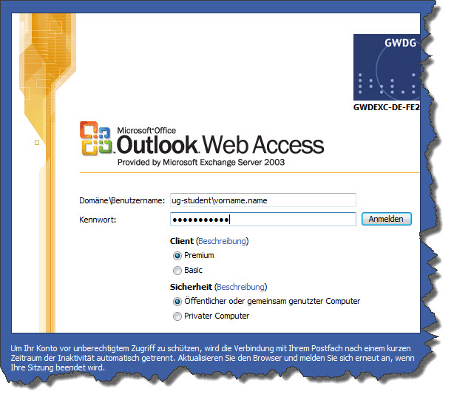
3. enter your user ID:
- ug-student\firstname.lastname
- password
4. edit your mails online
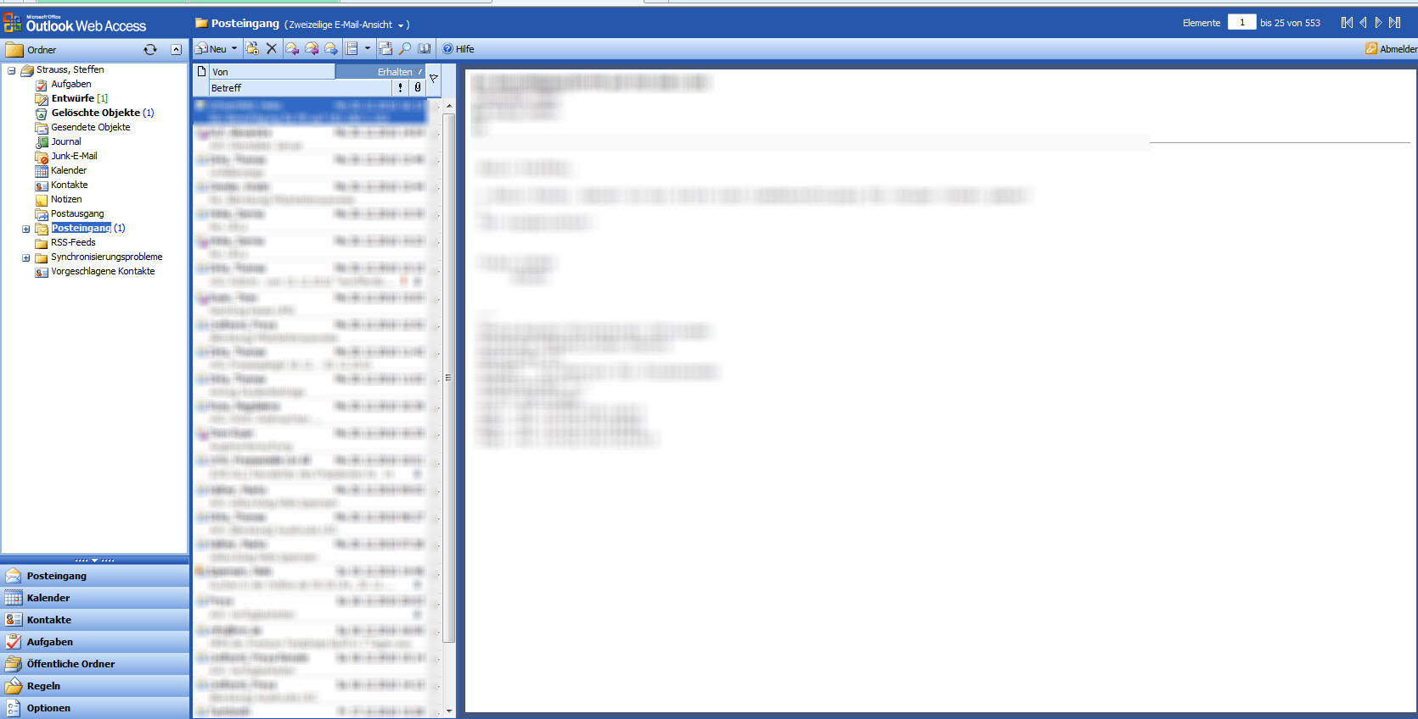
tag>mail mails address webmail microsoft outlook web access student account webmailer mailer exchange server

