Chip card issue point in the main lecture hall building (ZHG)
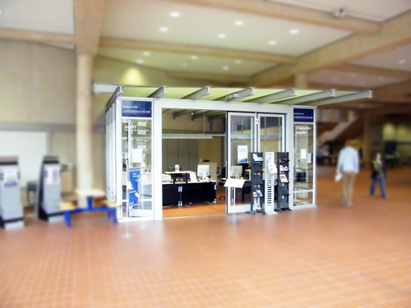
Location:
The Chip Card Issue Point has been closed since 01.06.2025

