Chip card issue point in the main lecture hall building (ZHG)
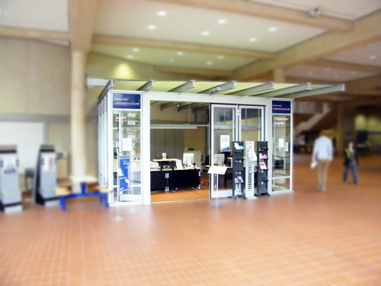
Location:

Opening hours:
Monday to Friday from 11 am to 2 pm.
There, studIT provides the following services:
- first-time issuing of your student ID
- renewing the student ID (only during consulting hours)
You can find us between lecture halls 010 and 011 in the main lecture hall building.

