How to use Wi-Fi networks (GoeMobile & eduroam) with Mac computers
If you have an Apple notebook, you can establish a connection to the Wi-Fi network GoeMobile as well. Here we also recommend an encrypted connection by using VPN. In the following you can find how to configure your Mac to use VPN.
This instruction differentiates between SnowLeopard (Mac OS X 10.6) and older Mac OS X versions.

1. Connect to the network "GoeMobile"
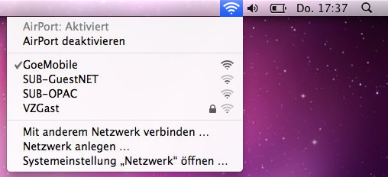
First choose the network „GoeMobile“ by clicking on the AirPort symbol in the menu bar.
If you cannot see the AirPort symbol in the menu bar, choose the network in your system preferences. Otherwise you can directly go to „configuration of VPN“.

Choose a network in your system preferences
Go to your system preferences (you can normally find them in your dock, in your programs folder or in the upper corner of your apple-menu). There choose „network“ and „GoeMobile“ under network name. If „GoeMobile“ does not appear in the list, you are probably not close enough to an access point of GoeMobile„ or you should switch on your AirPort.

VPN and different OS X versions
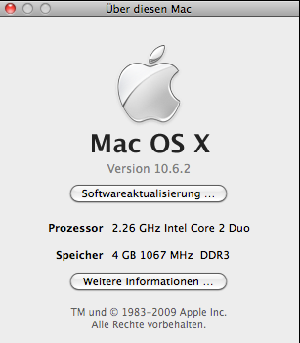
You can check your Mac OS X version by clicking on the apple symbol in your menu bar and choose „About this Mac“.

VPN under SnowLeopard (Mac OS X 10.6)
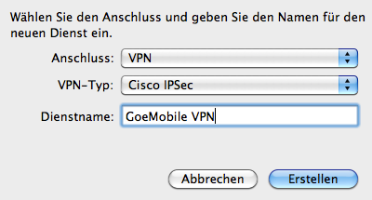
This installation version is a bit more time-consuming, but way more comfortable and reliable in everyday life. First connect to the network „GoeMobile“.
After that add a new network connection: system preferences→ network→ “+„ 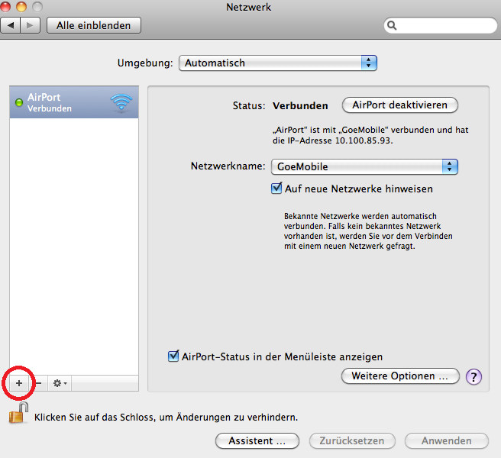
Enter the following data in the pop-up window:
Interface: VPN
VPN Type: Cisco IPSec
Service Name: GoeMobile VPN
You just added the VPN connection which needs to be configured now: the server address is vpn.gwdg.de, then enter your account name and your corresponding password.
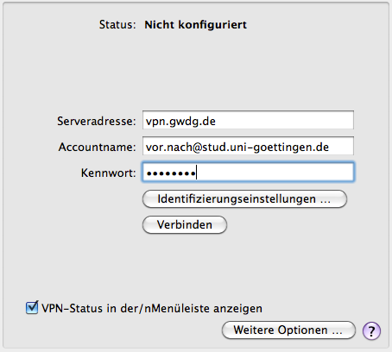
Important: Please tick the box „Show VPN status in menu bar“ so that you will be able to connect easily in the future.
After that click on „Authentication Settings“.
Here please insert „goemobile“ for „Group Name“ and „Shared Secret“. 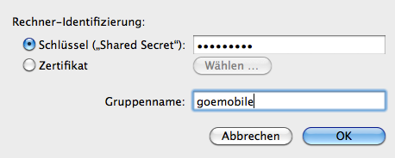
Finally please confirm your settings and close the system preferences. In your menu bar you now should see the „VPN security lock“. Click on it to connect with the VPN server.

VPN Wi-Fi network under Mac OS X 10.5 and older versions

Please open a browser (Safari, Firefox etc.) and enter into the address bar vpn.gwdg.de. After that, authorise with your student e-mail address and you password.
After that the Cisco VPN client will be installed on your computer. Please confirm the warning messages concerning the certificates of the GWDG. If necessary, enter your computer password again.

After completing the installation successfully you can find the symbol of the VPN client in your menu bar. Click on it to connect with the VPN client. After that an Internet connection should have been established.
POSSIBLE PROBLEM: If you have disconnected once, the VPN client does not connect again. One possible solution is to switch off and on the AirPort.

For users of Mac OS X 10.4 and older

HERE you can also download the Cisco VPN client for free. The necessary security certificates should be pre-installed. After downloading the file successfully, activate the disc image (.dmg) and install the software. Now start the program (you should find it in the folder „programs“). You should be able to see the following profile in the window of the VPN client:
„goemobile“ – this contains the connection data for accessing the Wi-Fi network „GoeMobile“ as well as the connection data for your access from DSL and modem connections (If you cannot see the profile, please import it manually: Click on „Import“, then go to the folder „Profiles“ in the installation image of the VPN client. There you should see the the opened .dmg-file in your mounted finder-directory, like an additional device. Then choose „goemobile.pfc“.).
Now click on „Connect“. After a short time a window should pop up where you have to log in with your data:
firstname.lastname@gwdg-stud
Password (the same for your account)
Please note: Do not use domains like “.de„ at the end!
After authenticating successfully you should be able to read „connected“ at the bottom of the window. Now you are connected to the network! By using the VPN client, your connection to the Internet will be encrypted for a secure data transmission.

eduroam and Mac
It is very easy to use eduroam on your Mac!
- click on the AirPort symbol at the top right hand side of the screen
- choose eduroam as network
- confirm the security certificate and enter your user name and your account password
tag>wi-fi network mac apple os x goemobile eduroam vpn snowleopard

